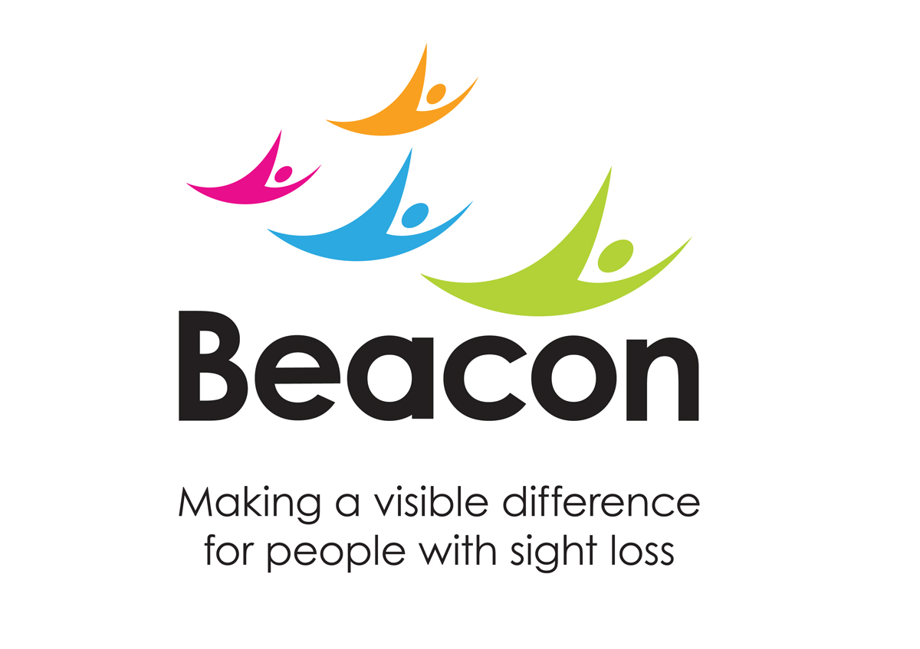

Terms and Conditions Santa Run 2022
Santa Run 2022 is organised by the Beacon Centre registered charity number 216092. Terms and Conditions of Entry.

- By registering for the Event, you are agreeing to the below terms and conditions

- You acknowledge that you will be contacted by email, phone, SMS, and post in relation to this event. This is to ensure that Beacon Centre for the Blind can deliver the necessary administrative and event-related communications for the event. This will include communications about but is not limited to completing your registration for the event with any third-party providers and fundraising advice and tips

- Your personal data will be processed in accordance with Beacon’s privacy policy. You acknowledge that we will share your contact details where necessary with other third parties involved in the administration of the Event. We will never share your data with any other third parties unless you agree. If you wish to discuss this further, please contact the fundraising team via the details below
- If you are registering other people into this event, you are accepting the terms and conditions on their behalf and are confirming that you have been given the authorisation to do so
- You agree to abide by any instructions given to you by the Race Organisers or officials during the event
- You acknowledge that any photography or film footage taken as part of your participation in the event can be used for promotional and marketing purposes for this specific event and any future Beacon event activity. This includes but is not limited to: Promotion on Beacon’s and / third-party websites, social media, online and print media publications and other marketing materials. If you do not wish for your image to be used in this way, please contact the Fundraising Team using the details below

- You acknowledge that failure to respond to communications from Beacon’s fundraising team about completing your registration or fundraising may put your event place at risk

- Participants under the age 16 years must be accompanied by a parent or guardian, who will take full responsibility for them throughout the event

- Under 16s must have their tickets purchased by a parent or guardian who has deemed them fit to take part and agreed to the terms and conditions on their behalf

- When fundraising, you will act lawfully and follow any fundraising guidelines provided by Beacon. You must make it clear that you are fundraising in aid of Beacon Centre for the Blind. You must not put under pressure on people to sponsor you or do anything that may harm the reputation of Beacon or act in a manner contrary to our values
- All participants are responsible for ensuring that they will be able to run safely with the option to wear a standard sized Santa suit which will be provided on the day
- If you have to withdraw prior to the event, you must notify Beacon immediately and before the registration deadline if possible

- You agree to ensure any cheques relating to any sponsorship money raised are made payable to Beacon Centre for the Blind and sent to the fundraising team with the event name, your full name, and address

- You need to be satisfied that you are physically capable of doing the event without undue risk to your health or life. It is the participants responsibility to ensure that Beacon Centre for the Blind are made aware of any health issues that may affect you at the event

- If you have a medical condition or are unsure of your physical ability to take part in the event, you must seek medical advice from a general practitioner prior to participating in the event

- All participants and spectators attend and enter the event entirely at their own risk. We shall not be liable for any injury or loss to persons or their property that might occur as a result of your or their participation in or attendance at the event, other than in respect of any injury or loss arising as a result of our negligence. For the avoidance of doubt, nothing in this clause shall exclude or limit our liability for any liability that cannot be excluded or limited by law

- Once the event is completed participants are allowed to take home their Santa hats, Santa outfits and medals. If suits, hats or medals run out on during the event you will be posted one at a later date. We are not responsible for any wear or tear for the suits during or after the event

- Outfits supplied by the Beacon come in adult sizes. If you feel you need a smaller size, we advise to bring your own that you feel most comfortable in

- All participants must check into the event. You may be asked to carry your details including your name and emergency contact number, if you disclose any health problems

- Beacon Centre for the Blind have the right to cancel the event at any time for reasons including but not limited to severe weather, terrorism, act of god, closure of the area by local and national Government restrictions

- In the event that the Santa Run is cancelled we will inform all runners via Social Media and the email address they registered with at the time of booking

- It is strongly recommended that you train and prepare for the run. If you have not exercised before or for some time, or have a pre-existing medical condition, you should consult your doctor prior to the event

- By registering an under 16-year-old as a participant, the parent or guardian confirms that they are happy for any footage or photographs taken which may feature the under 16 years old during their participation in the event to be used in this way

- Any dogs brought to the event must be kept on a lead at all times and you must pick up any foul

- We advise all participants to carry out a lateral flow test prior to the event, if you are feeling unwell, we advise participants to not attend the event to reduce the risk of spreading and germs. Do not attend if you have tested positive for or been asked to isolate as a result of Covid-19

- If in the event that Santa Run is cancelled due government guidelines, then we will offer a virtual element of the race. Participants will be contacted to check they are happy for their ticket cost and collected sponsorship to be considered a donation to Beacon Centre for the Blind.

- With the national risk of Avian flu within the area standard precautions will be taken on the day of the event. A full sweep of the running route will be conducted by park ranger and event leader along with a full briefing prior to the Santa Run.

- Santa Run participants to avoid close contact with sick or dead wild birds and will be asked not to touch their droppings, eggs or bedding. If you find any dead wild birds, do not touch them, and report them to a Beacon Centre for the Blind representative.

- A Foot Dip will be present at the event for those who wish to use it.

Please ensure all correspondence regarding your participation in the Event is directed to supportus@beaconvision.org or contact us on 01902 880111.
Thank you for choosing to support Beacon Centre for the Blind

