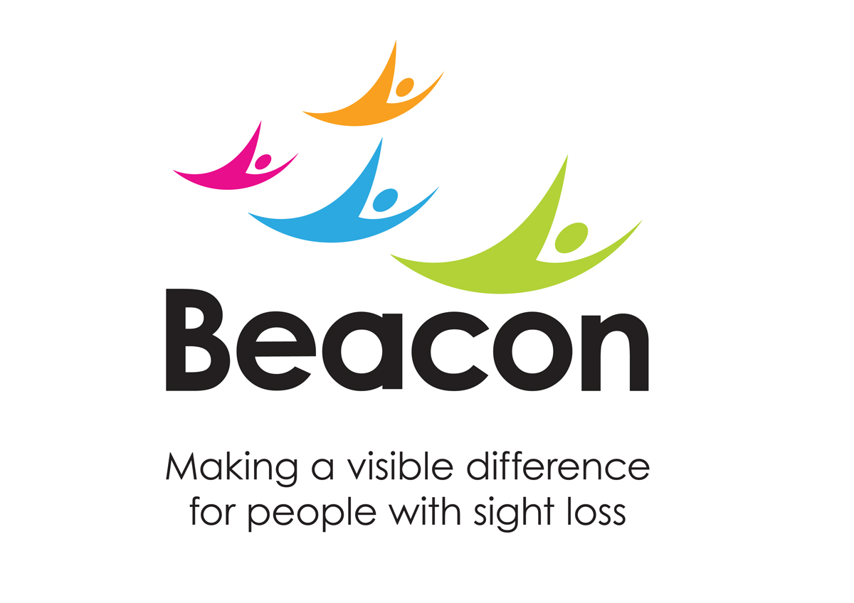

Beacon’s Family Fun Colour Run 2024

The Colour Run event is organised by the Beacon Centre registered charity number 216092. Terms and Conditions of Entry.
- By registering for the Event, you are agreeing to the below terms and conditions

- You acknowledge that you will be contacted by email, phone, SMS, and post in relation to the event you have registered for, ensuring Beacon Centre for the Blind can deliver the necessary administrative and event-related communications required to complete your successful participation and fundraising for the event. This will include communications about:

  - Completing your registration for the event with any third-party providers;
  - Fundraising advice and tips;

- Your personal data will be processed under Beacon’s privacy policy. You acknowledge that we will share your contact details with the organiser of the Event, and where necessary, with other third parties involved in the administration of the Event. We will never share your data with any other third parties unless you agree
- If you are registering other people into this event, you are accepting the terms and conditions on their behalf and are confirming that you have been given the authorisation to do so
- You agree to abide by any instructions given to you by the Race Organisers or officials during the event
- You acknowledge that any photography or film footage taken as part of your participation in the event can be used for promotional and marketing purposes for this specific event and any future Beacon’s events activity, including but not limited to promotion on Beacon’s and third-party websites, social media, in online and print media publications and other marketing materials. If you do not wish for your image to be used in this way, please contact the Fundraising Team

- You acknowledge that failure to respond to communications from Beacon’s Fundraising Team about completing your registration or fundraising may put your event place at risk

- You acknowledge the registration fee you have paid is non-refundable, non-transferable, and cannot be used towards your sponsorship pledge

- You will take responsibility for registering your contact details with the Organiser of the Event if required. Failure to do so will mean you cannot take part in the event. If this is necessary, we will inform you well in advance of what action is required
- Participants under the age of 16 years must be accompanied by a parent or guardian, who will take full responsibility for them throughout the event
- Under 16s must have their tickets purchased by a parent or guardian who has deemed them fit to take part and agreed to the terms and conditions on their behalf

- Only use the coloured powder provided by Beacon Centre, outdoors in open, well-ventilated areas

- Do not throw powder towards the face always target the shirt and lower body areas

- Colour powder should only be thrown in the designated areas; such as the colour stations and at the start/finish line at East Park, Wolverhampton

- Runners are advised to wear suitable clothing that you don’t mind getting messy, please do not wear any expensive or valuable clothing to this event

- The Coloured powder is manufactured from the raw materials that are approved for use in food and/or cosmetic applications. The powder used for this event are Non-Toxic, Non-Irritant to skin, Conforms to EN-71-3 Standards.

- The Coloured powder used at this event is non-toxic however, with any fine powder we recommend protective measures such as wearing a mask and goggles or similar, to protect eyes and avoid inhaling excessive quantities. Tie hair back wherever possible and protect with a bandana or cap. Bleached hair can be more porous and discolouration may occur. The colour is usually washed away with a shower after the event

- With soap and water, the colour will wash from hair and skin, a long soak in a hot bath is more effective than a shower in cleaning the skin. In cases of heavy powdering don’t worry if it doesn’t come out straight away. Temporary colouration of hair and skin can happen, repeat washing may be necessary

- Beacon Centre for the Blind is not responsible for the staining of clothing

- Beacon Centre also suggest that your transport is protected from the paint powder. For example, covering car seats in plastic to avoid participants’ cars becoming covered in powder paint

- Beacon Centre requests that participants avoid throwing paint close to vehicles, and to throw paint at the designated colour stations

- Event participants can bring mobiles phones and other technical equipment at their own risk. Beacon Centre cannot take responsibility for any damage to personal items. It is advised to wrap your camera/phones with cling film or placing your phone in a Ziplock bag

- If you are pregnant or have any issues with your health, we recommend you to consult your doctor before entering Beacon’s Colour Run. Although our mission is to make the race as safe as possible to every participant, there is always the possibility of unforeseeable incidents (such as falling or bumping into another person)

- By registering for Colour Run participants with asthma or respiratory conditions acknowledge that they have read and understood these terms and conditions. Participants with asthma or respiratory conditions should be mindful of their limitations and avoid overexertion during the event.
- All participants must declare any health conditions upon registration
- You are welcome to bring your own refreshments to consume on or after the run, but NO alcohol will be permitted during the run

- Dogs are not permitted to participate in the colour run race. Dog owners who bring their pets into the park where the colour run event is held do so at their own risk. Dogs may be sensitive to the environment including loud noises, crowds and coloured powder used during the event.

- If you would like to take part in the Colour Run and would like to be paired up with a partner to run the race, then please contact the fundraising team

- When fundraising, you will act lawfully and follow any fundraising guidelines provided by Beacon. You must make it clear you are fundraising in "aid of Beacon Centre for the Blind" and are not representing that you are raising funds on behalf of Beacon. You must not put under pressure on people to sponsor you or do anything that may harm the reputation of Beacon or act in a manner contrary to our values

- If you have to withdraw prior to the event, you must notify Beacon immediately and before the registration deadline if possible

- You agree to ensure any cheques relating to your sponsorship are made payable to Beacon Centre for the blind and sent to the Fundraising Team with the event name, your full name, and address

- The event which you are registering for is physically challenging and may pose a risk of discomfort, illness or injury. You need to be satisfied that you are physically capable of doing the event without undue risk to your health or life. We do not conduct health or fitness checks on entrants and the responsibility for your ability to participate in the event is with you as the participant

- If you have a medical condition or are unsure of your physical ability to take part in the event, you must seek medical advice from a general practitioner prior to participating in the event

- All participants and spectators attend and enter the Event entirely at their own risk. We shall not be liable for any injury or loss to persons or their property that might occur as a result of your or their participation in or attendance at the Event, other than in respect of any injury or loss arising as a result of our negligence. For the avoidance of doubt, nothing in this clause shall exclude or limit our liability for any liability that cannot be excluded or limited by law

- Once the event is completed participants are allowed to take home their colour run medals
- You agree that should the event be cancelled due to an event beyond the reasonable control of the organisers, including but not limited to severe weather, terrorism, act of God, COVID-19, that tickets are non-refundable
- It is strongly recommended that you train and prepare for the run. If you have not exercised before or for some time, or have a pre-existing medical condition, you should consult your doctor prior to the event
- By registering an under 16-year-old as a participant, the parent or guardian confirms that they are happy for any footage or photographs taken to be used for promotional and marketing purposes for this specific event and any future Beacon’s events unless otherwise stated
- Participants in the Colour Run event must wear sunglasses at all times during the race for their safety and protection. The coloured powders used in the event may cause irritation to the eyes, and wearing sunglasses is a mandatory precautionary measure. Participants not wearing sunglasses will be asked to stop the race until they comply with this safety requirement.
- Participants who fail to comply with the sunglasses policy may be disqualified from the event, and their registration fees may be forfeited. It is the responsibility of each participant to come prepared with appropriate eyewear to fully enjoy and safely participate in the Colour Run. These terms and conditions are in place to prioritize the safety and well-being of all participants, creating an enjoyable and secure environment for the Colour Run event

Thank you for choosing to support Beacon Centre for the Blind

