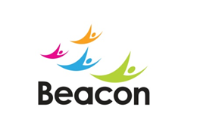

Volunteer Role Description

Role: Bus Buddy

Responsible to: Health and Wellbeing department managers

Hours Available: Flexible (to meet the needs of the client)

Purpose: To provide support and assistance to the member while using transport to and from the centre and to accompany on day trips and occasional outings.

Summary of Duties:

- To support members using transport services between the Lifestyle Centre, local communities and community activities
- To accompany members and support with recreational activities eg, day trips, shopping outings and general social inclusion
- To support and guide members on and off transport
- To assist, reassure and guide members during the journeys, trips and outings whilst encouraging them to gain confidence and build independence.

The Role:

- You will enjoy meeting new people.
- For day trips and outings all travel and entrance costs will be met.
- This is an exciting opportunity to gain experience of working with visually impaired people and those with other disabilities.
- Good communication and listening skills and a friendly approachable manner are necessary.
- Being trustworthy and reliable is also essential.
- Experience of working with people with disabilities would be an advantage.
- An enhanced DBS disclosure is required for this role.

