

Welcome to May 2026
Would you like to receive this newsletter in a different format? Please contact us on 01902 880111 or email enquiries@beaconvision.org

Welcome to May! As the days grow longer and the world outside bursts into colour, it is the perfect time to refresh, refocus, and reconnect.

let us continue the good times as we roll into the summer.

(Above is a branch wonderfully decorated by our daycentre members)
VIP Sessions
These sessions are held monthly, and the activities are designed with you to ensure we meet your needs. Our VIP group is a friendly bunch of people with sight loss who like to try new activities, build friendships, and encourage others to live life to the full. Each meeting costs £3.50. If you want to be part of a community that understands your experiences and you wish to attend or find out more, please email Daniel Clarke, dclarke@beaconvision.org or call 01902 880 111.
VIP Queens Cross
This group meets at Queen’s Cross Network, Wellington Road, DY1 1RB in the Café Plaza. 1st Friday of each month 1pm – 3pm. Refreshments are available to purchase at the venue. On Friday the 1st May we will be having a Health and Wellbeing session with our very own Dan.
VIP Brett Young
This group is at Brett Young Gateway, Old Hawne Lane, Halesowen, B63 3ST. You can purchase tea and coffee at the venue! Session is 1pm – 3pm. Every 2nd Monday of the month. On Monday 11th May we will be having a Health and Wellbeing session with our very own Dan.
VIP Beacon
This group is at the Beacon Centre, Wolverhampton Road East, Wolverhampton, WV4 6AZ. On Wednesday 27th May we will be going to the Queens Cantonese restaurant in Wolverhampton, 41 Queen Street WV1 3JY from 6pm – 8pm. Leaving Beacon at 5:30pm. Cost is £3.50 for staffing and support. Meal cost paid direct to restaurant.
VIP Stourbridge

This is an Exciting new group spreading out to our friends in the Stourbridge area.

This group will be located at the Sunshine Club in Stourbridge, 6 Crowle Drive, DY9 7NY. The sessions will run 10am – 12pm on the second Monday of each month. This month’s session will be held on Monday 11th May. We will be running a series of Health and Wellbeing workshops over the coming months.

VIP Kingswinford

This is another exciting new group spreading out to our friends in the Kingswinford Area.

This group will be located at the Kingswinford Medical practice, Stand hills road, Kingswinford, DY6 8DN. These sessions will run 10am – 12pm on the first Friday of each month.

This month’s session will be on Friday 1st May. We will be running a series of Health and Wellbeing workshop over the coming months.

May Sessions

To book on, contact Daniel Clarke, dclarke@beaconvision.org or call 01902 880 111.
Beacon events are designed to be as accessible and enjoyable as possible for people living with sight loss.

To help make this happen, we always ensure members of the Beacon team are on hand to support participants throughout each activity — whether that is guiding, offering help with practical arrangements, or making sure everyone feels confident and included. The cost to Beacon listed for each event helps us cover the staffing and support we provide to make the experience sight friendly. Where transport is provided, this is charged separately at cost price.

We will be holding a booking session for our May activities on Thursday 30th April 10am – 12pm in Beacon Court’s Communal Lounge.

Fishing

Come and join us for a fun but also relaxing day of fishing. Whether you are a seasoned fisher or new to fishing and want to give it a go a fully qualified coach along with beacon staff. We will be there to support you.

Beacon has received funding to support with costs for the fishing activities until October. This will cover the transport cost of £7.70 plus pay for the coach £80 per session.

Wednesday 6th May and Wednesday 20th May
Departing Beacon at 10:30am, returning at 2:30pm
Cost £3.50 (for staffing and support)
Plus £10 for equipment hire paid to the venue.



Book Club
Thursday 7th May
Venue: Beacon Court Communal Lounge 10:30am – 12:30pm
Cost: £2.50 (for staffing and support)
Join us as we love to talk all things books and always on the hunt for new authors and stories. Tea, coffee and biscuits will be available.



Tandem
Monday 11th May and Monday 18th May:
Departing Beacon at 10am, returning at 1pm

Cost £3.50 (for staffing and support) plus £7.70 for transport
Join us for our Tandem bike rides with our qualified instructors who will support you throughout your ride.

West Park Walk
Friday 15th May
Departing Beacon at 10:30am, returning at 2pm.
Cost £2.50 (for staffing and support) plus £5.50 transport.

Join us for a gentle stroll around West Park, with plenty of time to enjoy the scenery and socialise. Our staff will be there throughout to assist and ensure the walk is accessible for everyone.


Cooking
Monday 18th May
1pm – 3pm
Venue: Lifestyle Kitchen
Cost: £2.50 to Beacon
We will be cooking a sponge cake in our lifestyle kitchen please come along and cook up a storm.



Black Country Museum Trip
Tuesday 19th May
We will be having a trip to the Black Country Museum. Cost: £2.50 to Beacon (for staffing and support), plus £5.50 for transport.

Departing Beacon for 10.30am and returning for 2.30pm.

The cost to Black Country Museum is £25.95 for over 65’s and £26.95 for 16+. Or if you already have an unchained pass from our last visit that is valid for 12 months from first purchase.

Garden Centre
Thursday 21st May
Venue: Bridgnorth Garden Centre, Bridgnorth Road, Wolverhampton, WV6 7EJ

Departing Beacon for 10:30am, returning for 2:30pm.
We will be going to Bridgnorth Garden Centre, so please come along and stock up for your spring/summer essentials.

Bowling £7.25 (paid directly at the venue)
Friday 22nd May
Venue: Tenpin Dudley, Castle gate way, Dudley, DY1 1TA
Departing Beacon at 10:30am, returning at 1:30pm
Cost: £2.50 (for staffing and support), plus £5.50 transport

Come and join us for a fun morning of ten pin bowling. Whether you are a seasoned pro or a first-time player, everyone is welcome our friendly group is always keen to find new teammates. Could you be the one to get the top score?

Beacon staff will be on hand throughout to support you and make sure the session is accessible and enjoyable.



Baggeridge Walk

Friday 28th May
Departing Beacon at 10:30am, returning at 2pm.
Cost £2.50 (for staffing and support) plus £5.50 transport.

Join us for a gentle stroll around Baggeridge , with plenty of time to enjoy the scenery and socialise. Our staff will be there throughout to assist and ensure the walk is accessible for everyone.

Further Notes for May

On Wednesday 27th May from 1pm – 2:30pm in Lifestyle Social room we have the wonderful Wolverhampton Ukelele U3A visiting us.

Please enquire at Beacon reception.

The group, known for their lively performances and wide-ranging repertoire, will be playing a selection of well-known songs spanning different eras and genres,

all accompanied by the cheerful sound of the Ukulele.

This promises to be an enjoyable and uplifting afternoon, and we look forward to seeing as many members there as possible.

Beacon Gym
Contact: Daniel Clarke, dclarke@beaconvision.org or call 01902 880 111 to book in.
Want to exercise in a fun and supportive atmosphere? Want to join classes or exercise independently? Are you someone who works out regularly or wants to start?
The gym is open Monday to Friday, 9am – 4pm. Single sessions cost £5 or a monthly membership from £22.
You must complete a health questionnaire and an induction before you start. Please sign in to use the gym at our main reception desk.

Chair Exercises
Wednesday 13th May: 10am – 11am
Venue: Beacon Court resident’s lounge
This is a taster session so will have no cost.

Indoor Bowls
Monday 18th May: 10am – 12pm

Venue: Beacon Gym
Cost: £2.50 (for staffing and support)
(a picture of a man playing bowls below)


Ingredients for May Cooking session

Sponge cake

225g Softened Butter
225g golden caster sugar
4 large eggs
½ lemon
zested
1 tsp vanilla extract
225g self-raising flour
splash of milk
Optional fillings of lemon curd
jam, lightly whipped cream
icing sugar
for dusting

Please come along and cook up a storm in our lifestyle kitchen. Please remember a container to take food home with you.

Method for May Cooking session

Step 1
Heat oven to 180C/160C fan/gas 4, butter and line the base of two 20cm spring-form cake tins with baking parchment.

Step 2
Using an electric whisk beat the butter and sugar together until pale and fluffy. Crack the eggs in one at a time and whisk well, scraping down the sides of the bowl after each addition. Add the lemon zest, vanilla, flour, milk and a pinch of salt. Whisk until just combined then divide the mixture between the two tins.

Step 3
Bake in the centre of the oven for 25-30 mins until a skewer inserted into the middle of each cake comes out clean. After 10 mins remove the cakes from their tins and leave to cool completely on a wire rack. Fill how you like. My personal favourite is a good dollop of lemon curd and some fresh cream, then dust the top with icing sugar. Will keep for 3 days.

MEET THE STAFF
“I am Elke (as in Elkie Brooks), the E-Commerce and Referral Administration Intern.

I manage and run the Beacon Charity Finds eBay shop downstairs towards the back of the shop. This is part of my current internship, which is linked with the Thomas Pocklington Trust in London.

I love what I do – and I absolutely love the people I’m with down here in the shop. Sometimes, I get to help out at the till in the shop and look forward to starting the referral side of my role soon.

My interests are psychology, emotional intelligence, brain and leadership work and ancient wisdom. I co-authored in five books and I run the podcast “Exploring Brain and Mind”, available on Apple, Spotify, Amazon Music and YouTube.

Fun fact: I once drove a car blind-folded and by commends on an off-road track as part of a team exercise – and our team won!”

SIGHTLOSS
Come talk to our amazing low vision team to get support with your sight loss.
Email enquiries@beaconvision.org or call 01902 880 111 to make a free appointment.

Try some of these tips to support you in your everyday life!

Do you struggle to see writing that is in biro pen? Why not try felt pen? You’re writing will be bolder, larger and easier to read!

Do you struggle with contrast? What would be helpful is using contrasting chopping boards for all different food Want an example? What about a red chopping board for cauliflower, and a white chopping board for red pepper?

Do you struggle with glare? In our low vision, we have filter glasses that go over your own glasses that can greatly reduce glare and make life way more comfortable! There are other ways to help with glare too!

Like baseball, sunhat or visors!






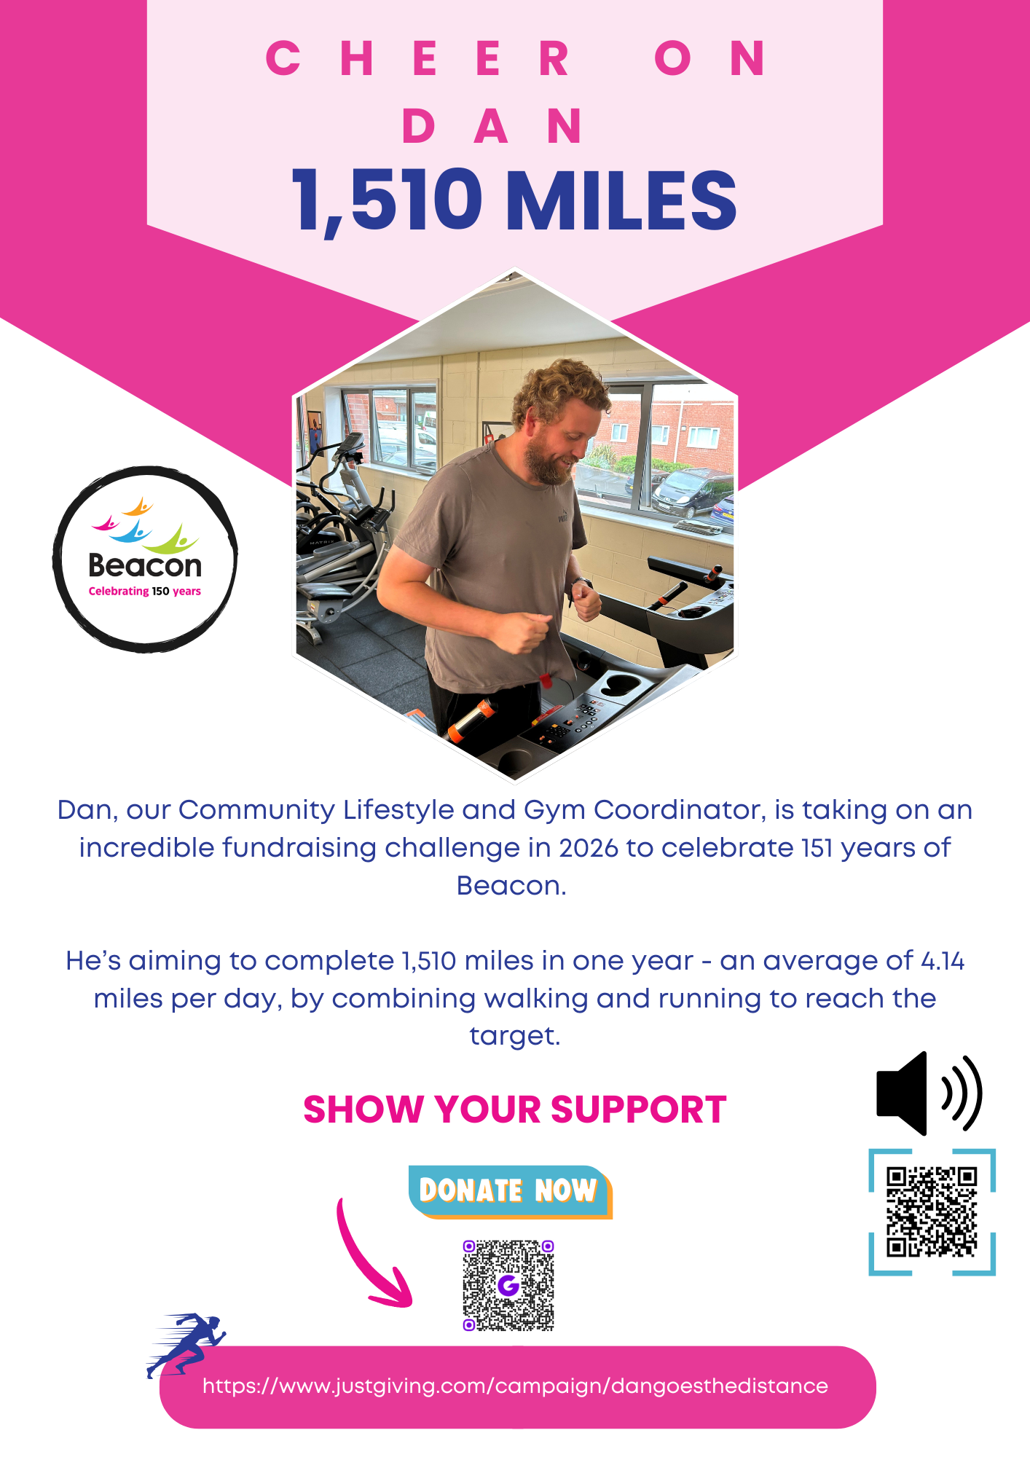


Sedgley Lifestyle Centre

We are now open Monday, Tuesday, Wednesday, Thursday, and Friday 10am-3pm at our base in Sedgley. We run several activities each day including cooking, crafting, pottery, computer work, using the gym, listening to music, quizzes, and reminiscing. We keep well hydrated with tea, coffee and water and we have the restaurant to attend for a hot meal if we do not bring sandwiches with us.
We are lively, fun and love to have a laugh. Why not come and join us for a trial day.
Contact the Beacon reception and ask for more details. Call 01902 880111 or email enquiries@beaconvision.org

Befriending Service

Have you got a free 30 minutes in the week?
Do you want to help combat loneliness?
Come volunteer at befriending service that is designed to help older people who might be feeling lonely! You can do this over the phone.
This volunteering is flexible to suit you while you offer friendship and support. You will be paired with someone based on common interests.
If you are interested, contact our team by calling 01902 880 111 or emailing enquiries@beaconvision.org
Contact Us
Address: Beacon Centre, Wolverhampton Road East, Wolverhampton, WV4 6AZ
Phone number: 01902 880 111.
Email: enquiries@beaconvision.org
Website: www.beaconvision.org
To find us on Facebook, Twitter, and Instagram: @BeaconCentre
(Pictures of Facebook, Twitter and Instagram logos below)

Accommodation at Beacon Court
Each apartment at Beacon Court has its own front door, individual access card, two bedrooms, store, wet/shower room. Kitchen with appliances, gas central heating, and double-glazed windows.
Beacon provides a 24/7 care team on-site to deal with any emergencies 365 days a year. There is a pull cord in each apartment that can raise in an emergency.
You also get 30 minutes a week of wellbeing time to go through anything you like such as help with post or paying bills. If you want any further information on accommodation at Beacon Court, please contact Chris Lamb on 01902 882 170 or email christopher.lamb@bromford.co.uk

