

Welcome to June 2026
Would you like to receive this newsletter in a different format? Please contact us on 01902 880 111 or email enquiries@beaconvision.org.

As summer begins to bloom, we’re excited to share fresh updates, upcoming events, and inspiring stories with you.
Here’s to longer days, new opportunities, and a month filled with fun and laughter.

(Below is a picture of a member on our recent fishing trip.)

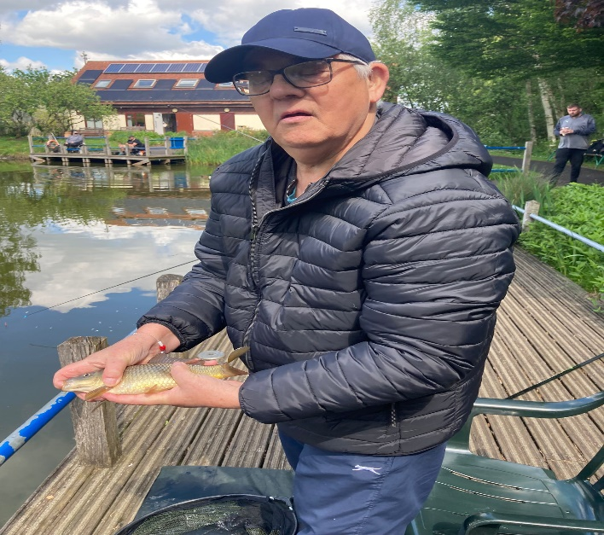
VIP Sessions
These sessions are held monthly, and the activities are designed with you to ensure we meet your needs. Our VIP group is a friendly bunch of people with sight loss who like to try new activities, build friendships, and encourage others to live life to the full. Each meeting costs £3.50. If you want to be part of a community that understands your experiences and you wish to attend or find out more, please email Daniel Clarke, dclarke@beaconvision.org or call 01902 880 111.
VIP Queens Cross
This group meets at Queen’s Cross Network, Wellington Road, DY1 1RB, in Café Plaza on the first Friday of each month, from 1pm to 3pm. Refreshments are available to purchase at the venue. On Friday 8th June, we will be having a Health and Wellbeing session with our very own Dan.
VIP Brett Young
This group meets at Brett Young Gateway, Old Hawne Lane, Halesowen, B63 3ST. Tea and coffee are available to purchase at the venue. Sessions run from 1pm to 3pm on the second Monday of each month. On Monday 8th June, we will be having a Health and Wellbeing session with our very own Dan.
VIP Beacon
This session will take place on Wednesday 24th June. We will be going to Aashiqs for a meal in Upper Gornal, DY3 1UY. We will be making our own way there by bus. 6pm – 8pm. Cost £3.50 (for staffing and support)
VIP Stourbridge

This is an exciting new group reaching out to our friends in the Stourbridge area.

This group will be located at the Sunshine Club in Stourbridge, 6 Crowle Drive, DY9 7NY. The sessions will run 10am – 12pm on the second Monday of each month. This month’s session will be held on Monday 8th June. We will be running a series of Health and Wellbeing workshops over the coming months.

VIP Kingswinford

This is another exciting new group reaching out to our friends in the Kingswinford area.

This group will be located at Kingswinford Medical Practice, Standhills Road, Kingswinford, DY6 8DN. These sessions will run from 10am – 12pm on the first Friday of each month.

This month’s session will be on Friday 5th June. We will be running a series of Health and Wellbeing workshops over the coming months.

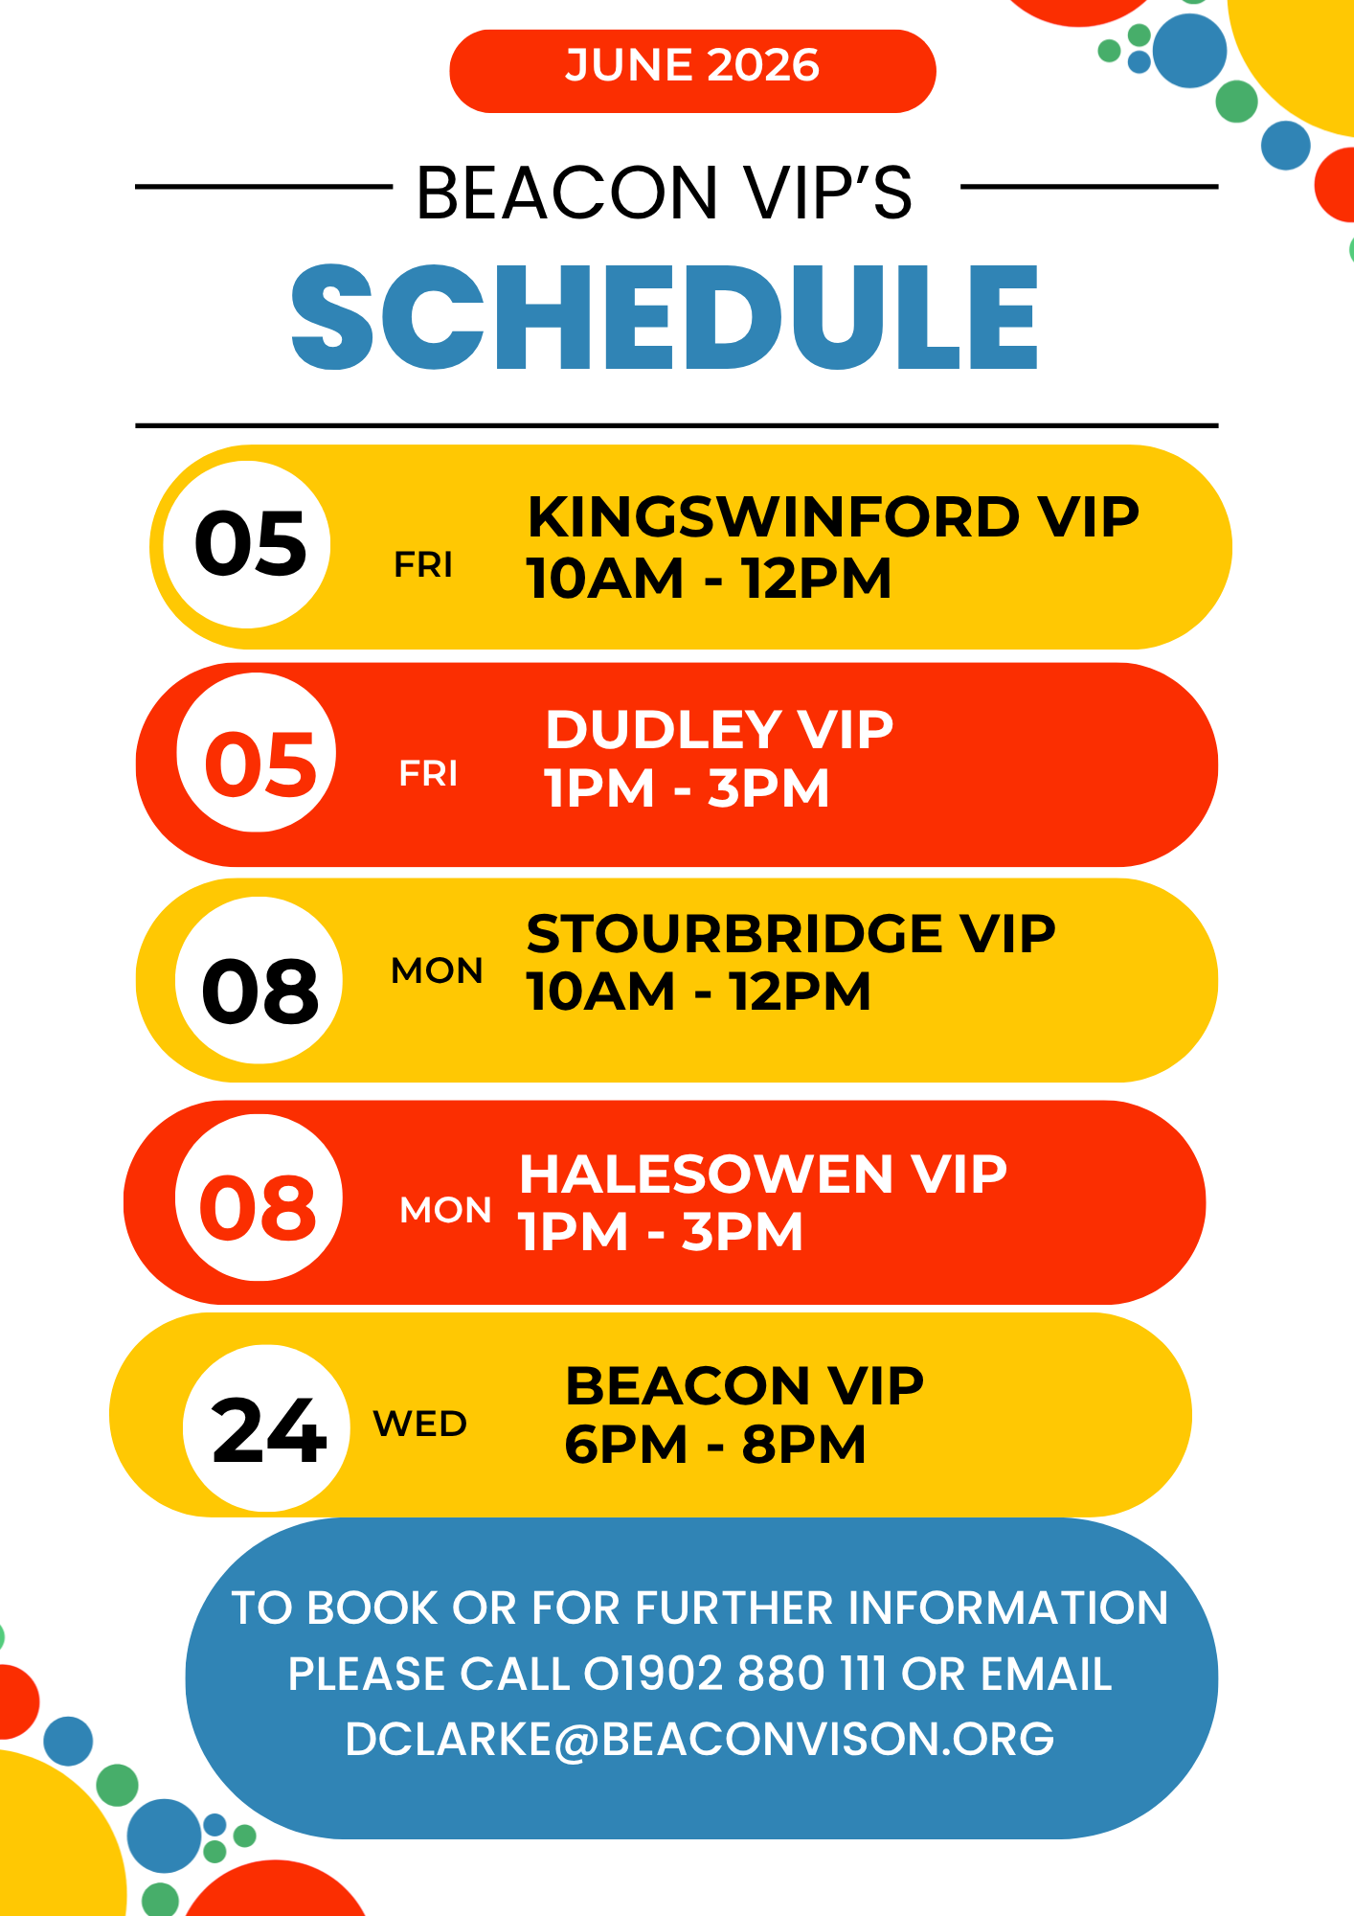

June Sessions

To book on, contact Daniel Clarke, dclarke@beaconvision.org or call 01902 880 111.
Beacon events are designed to be as accessible and enjoyable as possible for people living with sight loss.

To help make this happen, we always ensure members of the Beacon team are on hand to support participants throughout each activity—whether that means guiding, offering help with practical arrangements, or making sure everyone feels confident and included. The cost to Beacon listed for each event helps us cover the staffing and support we provide to make the experience sight-friendly. Where transport is provided, this is charged separately at cost price.

We will be holding a Coffee Morning/Booking Session on Thursday 28th May 10am – 12pm to discuss and organise our activities for June and beyond.

So please come along for a cup of tea, a biscuit, and a chat.


Fishing

Come and join us for a fun but relaxing day of fishing. Whether you are a seasoned angler or new to fishing and want to give it a go, a fully qualified coach, along with Beacon staff, will be there to support you.
Beacon has received funding to help cover the costs of the fishing activities until October. This will cover the transport cost of £7.70 and the coach fee of £80 per session.

Wednesday 3rd June and Wednesday 17th June
Departing Beacon at 10:30am, returning at 2:30pm
Cost £3.50 (for staffing and support)
Plus £11 for equipment hire paid to the venue.

This project has been funded by The Primary Club, The cricketer’s charity for the blind and partially sighted.



Book Club
Thursday 4th June
Venue: Beacon Court Communal Lounge 10:30am – 12:30pm
Cost: £2.50 (for staffing and support)
Join us as we talk about all thing’s books and hunt for new authors and stories. Tea, coffee, and biscuits will be available.



West Park Walk
Friday 12th June
Departing Beacon at 10:30am, returning at 2pm.
Cost £2.50 (for staffing and support) plus £5.50 transport.

Join us for a gentle stroll around West Park, with plenty of time to enjoy the scenery and socialise. Our staff will be there throughout to assist and ensure the walk is accessible for everyone.


Tandem
Monday 15th June and Monday 22nd June
Departing Beacon at 10am, returning at 1pm

Cost £3.50 (for staffing and support) plus £7.70 for transport
Join us for our Tandem bike rides with our qualified instructors who will support you throughout your ride.

Sedgley Adventure Centre
Thursday 18th June
Departing Beacon at 10:30am, returning at 1:30pm
Cost £2.50 (for staffing and support), plus £5.50 for transport
There is a £3 entry fee to the farm to pay on the day.
Join us for a fun and relaxing day out at the Sedgley Adventure Centre.



Bowling £7.25 (paid directly at the venue)
Friday 19th June
Venue: Tenpin Dudley, Castlegate Way, Dudley, DY1 1TA
Departing Beacon at 10:30am, returning at 1:30pm
Cost: £2.50 (for staffing and support), plus £5.50 transport
Come and join us for a fun morning of ten-pin bowling. Whether you are a seasoned pro or a first-time player, everyone is welcome, and our friendly group is always keen to find new teammates. Could you be the one to get the top score?
Beacon staff will be on hand throughout to support you and make sure the session is accessible and enjoyable.



Bantock Park Walk and Museum Visit
Friday 26th June
Departing Beacon at 10:30am, returning at 2pm.
Cost £2.50 (for staffing and support) plus £5.50 transport.
Join us for a gentle stroll around Bantock Park, with plenty of time to enjoy the scenery and socialise.
We will also have the opportunity to have a look around Bantock House Museum at our own pace.
Our staff will be there throughout to assist and ensure the walk is accessible for everyone.

Cooking
Monday 29th June
Venue: Lifestyle Centre Kitchen
1pm – 3pm

We will be cooking a cheese and onion pasty. Please come along and cook up a storm in our Lifestyle Centre kitchen.
Ingredients and method are enclosed in this newsletter.

Further notes for June and Beyond
We are working with Wolverhampton Taxi Licensing to help combat unfair treatment for visually impaired people when using taxis. Wolverhampton will be carrying out test purchases and mystery shopper exercises in June, and we would love your help with this.
If you are interested in supporting this, please get in touch with Becky Green at bgreen@beaconvision.org or call 01902 880 111.

Tuesday 14th July: Sight Loss Council visit
Bromford’s resident’s lounge, 1pm – 2:30pm

We have PJ, a Sight Loss Coordinator on behalf of the Thomas Pocklington Trust, coming in to meet with members, so please come along and have your voice heard! In 2022, Thomas Pocklington Trust and Sight Loss Councils completed a survey called Listening Month to ask blind and partially sighted (BPS) people what matters to them. This has guided the policies and campaigns we focus on, centred around our core themes of health, the built environment, transport, employment, and education. This year, we are hoping to reach as many BPS people as possible during July 2026 and would love those with lived experience to help guide our future work and ensure their voices are represented.

What’s been going on in the Lifestyle Centre
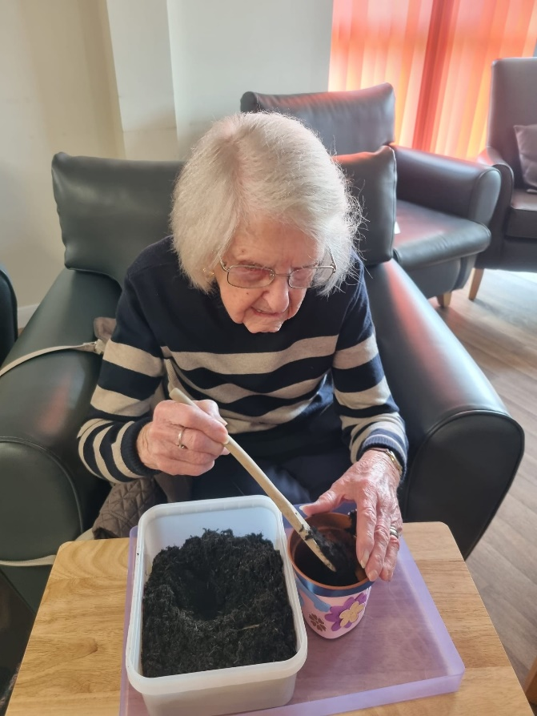
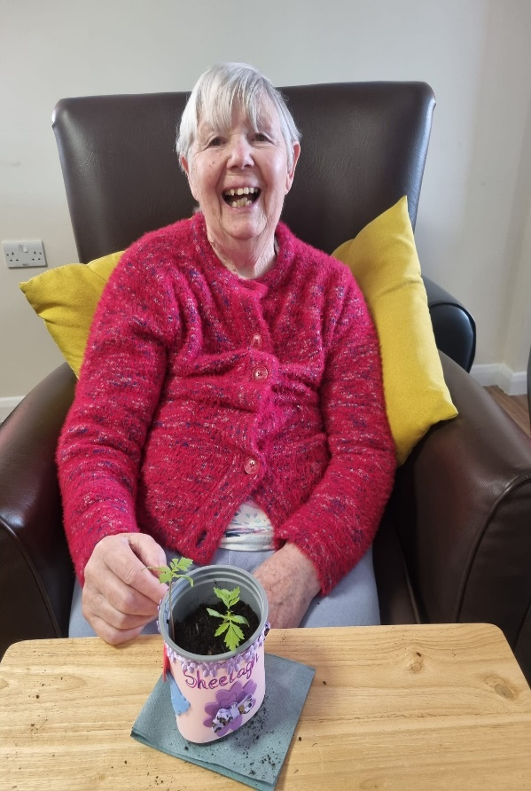
Above are our Lifestyle Centre members potting plants and decorating plant pots.

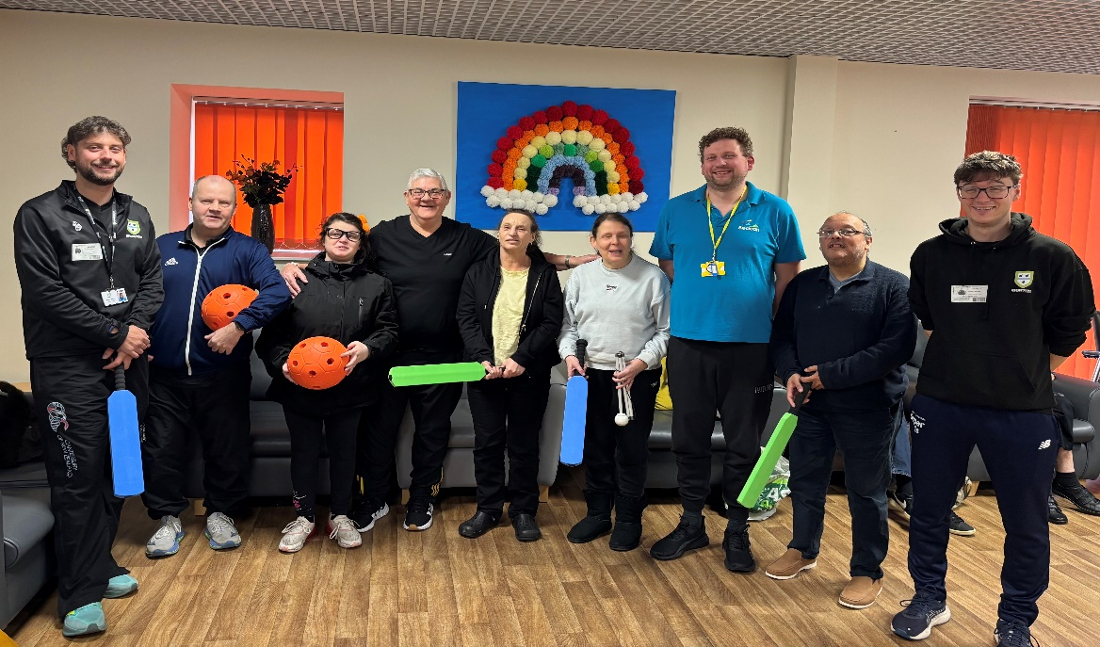
Our recent cricket session delivered by the Worcestershire Cricket Foundation.
Beacon Gym
Contact: Daniel Clarke, dclarke@beaconvision.org or call 01902 880 111 to book in.
Want to exercise in a fun and supportive atmosphere? Want to join classes or exercise independently? Are you someone who works out regularly or wants to start?
The gym is open Monday to Friday, 9am – 4pm. Single sessions cost £5 or a monthly membership from £22.
You must complete a health questionnaire and an induction before you start. Please sign in to use the gym at our main reception desk.
Chair Exercises
Wednesday 10th June: 10am – 11am
Venue: Beacon Court resident’s lounge
This is a taster session, so there will be no cost.

Indoor Bowls
Monday 1st and Monday 15th June 10am – 12pm

Venue: Beacon Gym
Cost: £2.50 (for staffing and support)
(a picture of a man playing bowls below)


Ingredients for June Cooking session

1 tbsp vegetable oil
2 onions
sliced
4 thyme sprigs
leaves picked
150g mature cheddar
(or a mixture of strong hard cheeses), grated
1 tbsp wholegrain mustard
4 spring onions
sliced

For the pastry
250g plain flour
plus extra for dusting
125g cold butter
large pinch of cayenne pepper
½ tsp English mustard powder
1 large egg

(or just bring your readymade pastry sheets)

Method for June Cooking session
Step 1
First, make the pastry. Tip the flour into a bowl. Holding the block of butter in its wrapper, grate it directly into the flour (you may need to dip the end of the butter into the flour occasionally if it becomes sticky). Add the cayenne pepper, mustard powder and half the beaten egg, and season with a pinch of salt. Bring everything together with your hands until the mixture starts to clump together. Tip the pastry onto the work surface and knead very briefly into a smooth ball, adding up to 3 tbsp cold water if it’s too dry. Squash the pastry into a disc. Wrap and chill while you make the filling.

Step 2
Heat the oil in a frying pan and cook the onions and thyme leaves for 8-10 mins until the onions have softened and started to caramelise. Tip into a bowl and leave to cool. Once cool, mix in the grated cheese, mustard and spring onions.

Step 3
Heat the oven to 200C/180C fan/gas 6 and line a baking tray with baking parchment. Roll the chilled pastry out on a lightly floured surface to the thickness of a £1 coin. Cut out as many 10-12cm circles as you can (you can use a cup or mug as a template), then re-roll any off-cuts and repeat. You should get about 10-12 circles in total.

Step 4
Spoon a mound of the filling into the centre of each pastry circle, leaving the edges clear. Working with one circle at a time, brush a little of the remaining beaten egg around the edge, then bring two sides up to meet in the middle in a half-moon shape. Pinch the pastry together, crimping the edge to seal. Transfer to the baking tray and repeat with the remaining pastry circles and filling. Brush all the pasties with some beaten egg. Will keep frozen for two months.

Step 5
Bake the pasties for 20-25 mins (or 40-45 mins from frozen) until the pastry is deep golden brown. Leave to cool for at least 10 mins before eating warm, or cool completely and pack into containers for a picnic. Will keep in an airtight container for up to three days.

Are You Interested?

We could look at various trips through the summer and beyond including activities such as:

- Canal Trips
- Dudley Zoo
- Cosford Air Museum
- Wolverhampton Adventure Golf
- Indoor Curling
- Boxercise Classes
- Circuit Classes

Please let me know if any of these are of interest to you so I can gauge interest and get the ball rolling. If you have any other suggestions, please let me know.

Please feel free to call 01902 880 111 or email me at dclarke@beaconvision.org, or speak to me whenever you bump into me.

Please come along to our Coffee Morning/Booking Session on Thursday 28th May so we can work together to get the best activities on for everyone.

Thank you, Dan 😊

Sandwell Deaf Community Association

Deafblind Group

Do you live in the Sandwell and Black Country area?Are you Deafblind?

Deaf blindness is a unique disability involving both sight and hearing loss that significantly impacts communication, information access, and mobility, even if hearing or vision is not totally lost.

For more information, please contact:
Text/WhatsApp/FaceTime:
07791921011

Or email craig_pthercary@sdca.co.uk


If this is something you would be interested in finding out more about, please contact Dan.
Dclarke@beaconvision.org

Meet The Staff

Hi, my name is Lydia. I have worked with Beacon for almost five years, starting as an Employment Coach before moving into Oral History work, and more recently into my current role in Employment and Skills.

The best part of my job is meeting the amazing people that use Beacon’s services. I enjoy getting to know people, understanding their journeys, and working with them to find practical solutions that help them move forward and reach their goals.

Outside of work, I enjoy walking, especially now the weather is improving. There’s nothing better than a stroll in the sunshine with my dog, Luther.

I also enjoy travelling and going on holiday, visiting new countries and ticking them off my list whenever I get the chance.



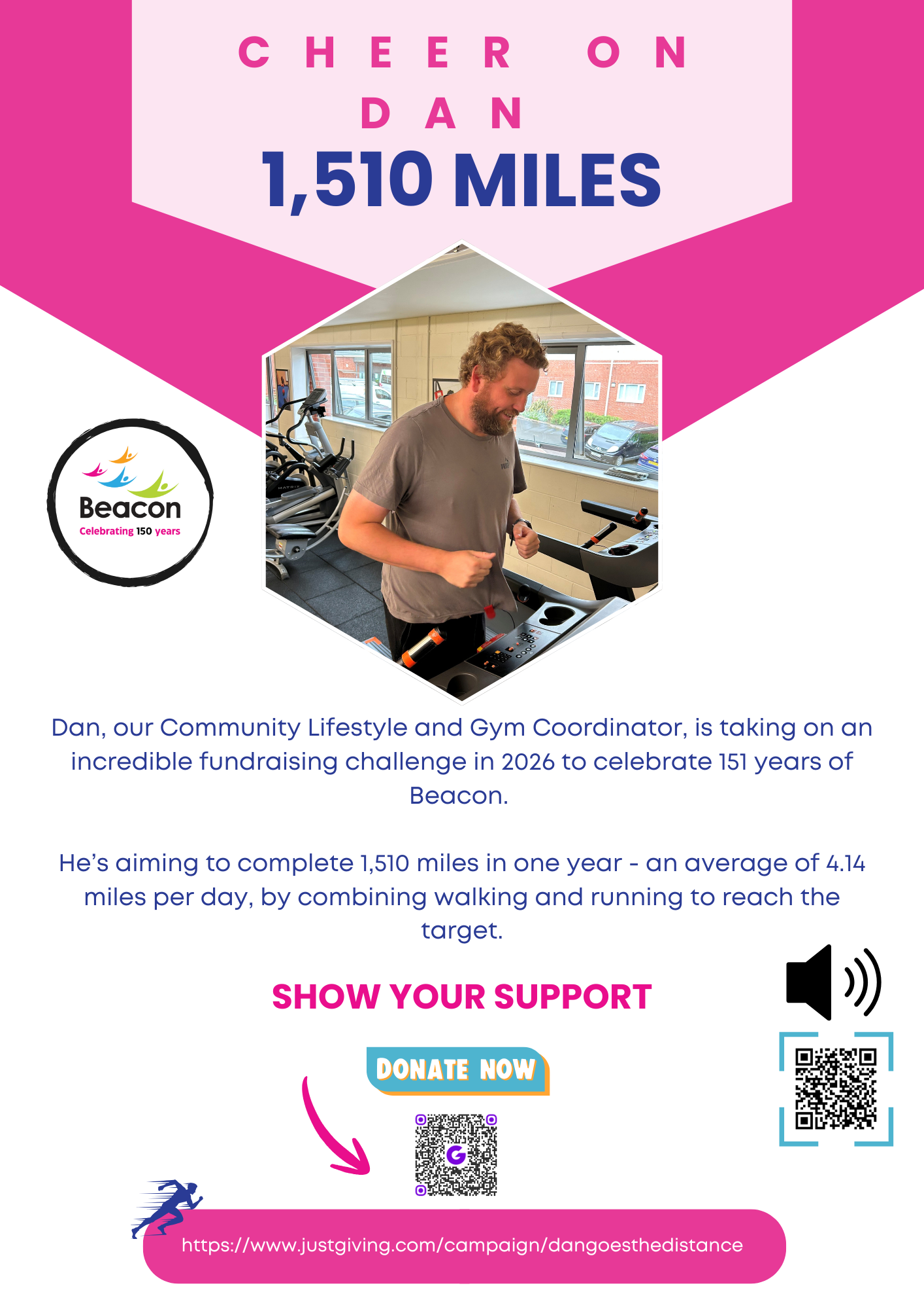
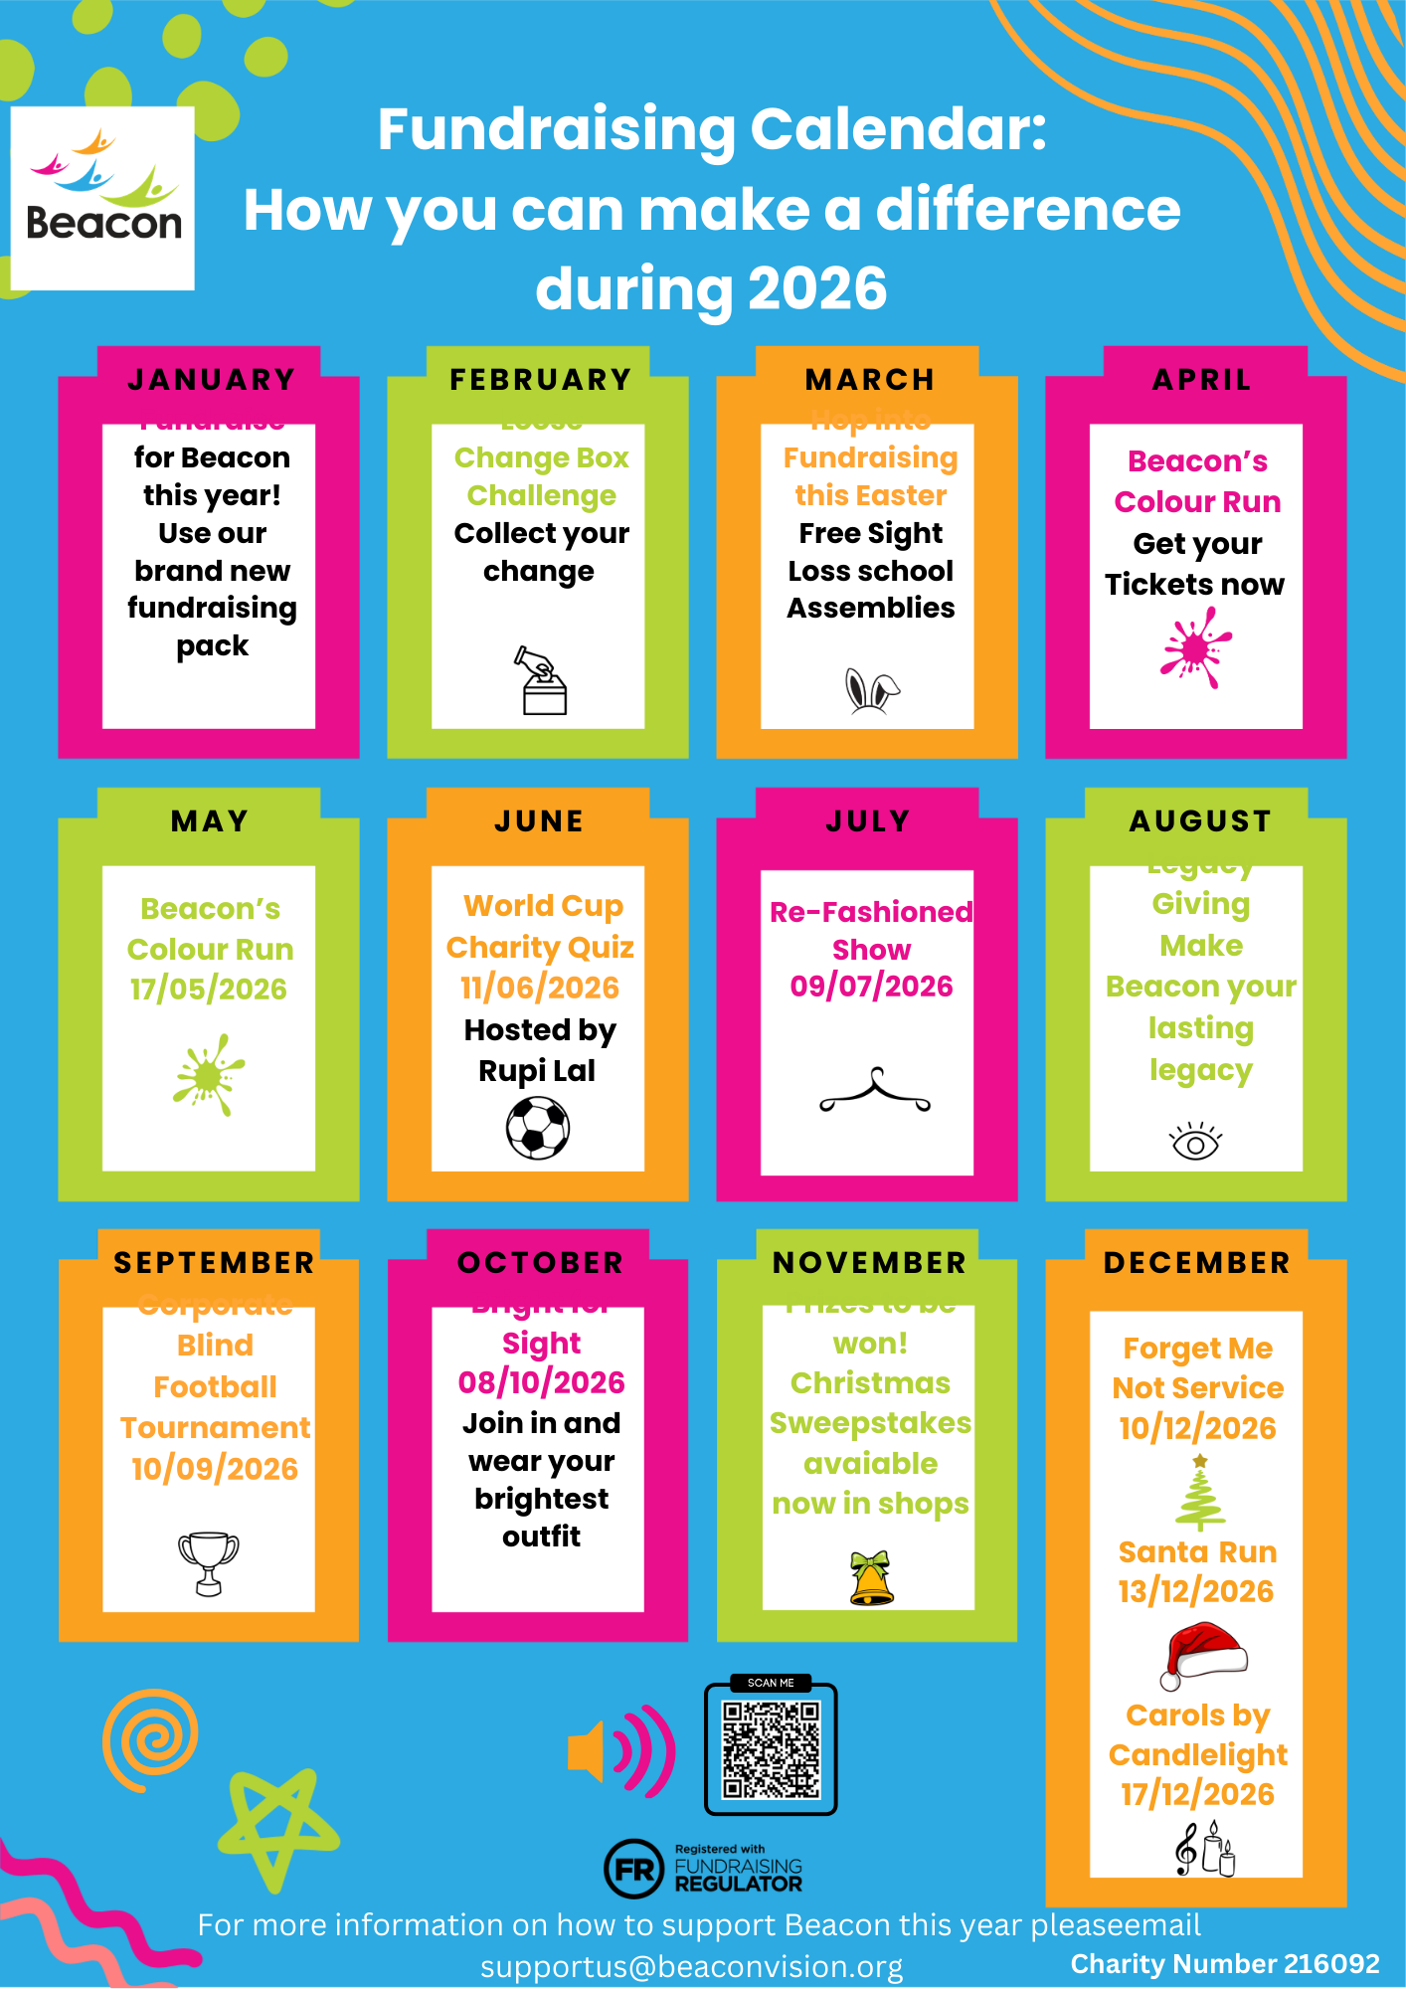




Sedgley Lifestyle Centre

We are now open Monday, Tuesday, Wednesday, Thursday, and Friday, 10am–3pm, at our base in Sedgley. We run several activities each day, including cooking, crafting, pottery, computer work, using the gym, listening to music, quizzes, and reminiscing. We keep well hydrated with tea, coffee, and water, and we have the restaurant to attend for a hot meal if we do not bring sandwiches with us.
We are lively, fun, and love to have a laugh. Why not come and join us for a trial day?
Contact Beacon reception and ask for more details. Call 01902 880 111 or email enquiries@beaconvision.org.

Befriending Service

Have you got a free 30 minutes in the week?
Do you want to help combat loneliness?
Come and volunteer with our befriending service, which is designed to help older people who might be feeling lonely. You can do this over the phone.
This volunteering is flexible to suit you while you offer friendship and support. You will be paired with someone based on common interests.
If you are interested, contact our team by calling 01902 880 111 or emailing enquiries@beaconvision.org.
Contact Us
Address: Beacon Centre, Wolverhampton Road East, Wolverhampton, WV4 6AZ
Phone number: 01902 880 111.
Email: enquiries@beaconvision.org
Website: www.beaconvision.org
To find us on Facebook, Twitter, and Instagram, follow @BeaconCentre.
(Pictures of Facebook, Twitter and Instagram logos below)

Accommodation at Beacon Court
Each apartment at Beacon Court has its own front door, individual access card, two bedrooms, a store, a wet room/shower room, a kitchen with appliances, gas central heating, and double-glazed windows.
Beacon provides a 24/7 care team on-site to deal with any emergencies, 365 days a year. There’s a pull cord in each apartment that can be used in an emergency.
You also get 30 minutes a week of wellbeing time to go through anything you like, such as help with post or paying bills. If you want any further information on accommodation at Beacon Court, please contact Chris Lamb on 01902 882 170 or email christopher.lamb@bromford.co.uk.

