

Welcome to November 2026
Would you like to receive this newsletter in a different format? Please contact us on 01902 880111 or email enquiries@beaconvision.org
As the season turns crisp and cosy,
welcome to our November newsletter! Inside you’ll find updates, highlights, and what’s coming up including festive plans and ways to get involved.
Below is an autumnal display created by our daycentre members

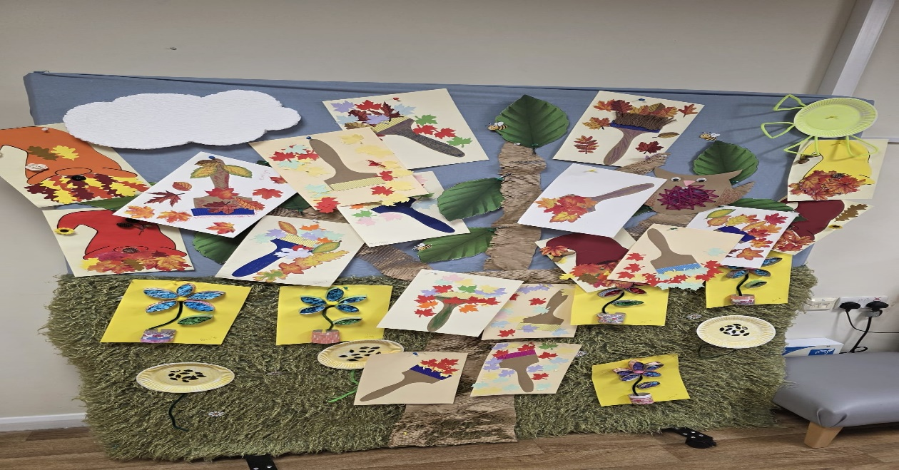
VIP Sessions: cost £3.50
These sessions are held monthly, and the activities are designed with you to ensure we meet your needs. Our VIP group is a friendly bunch of people with sight loss who like to build friendships and connect with like-minded people.
VIP Queen’s Cross
This group meets at Queen’s Cross Network, Wellington Road, DY1 1RB in the Café Plaza. Friday 6th November 1pm – 3pm.
VIP Brett Young
This group is at Brett Young Gateway, Old Hawne Lane, Halesowen, B63 3ST. You can purchase tea and coffee at the venue! Monday 9th November 1pm – 3pm
VIP Beacon
This group is at the Beacon Centre, Wolverhampton Road East, Wolverhampton, WV4 6AZ. Thursday 26th November
We will be going out for a Christmas Meal at the Newbridge Pub, Tettenhall, Wolverhampton WV6 0JU. Table Booked for 12:00pm. This is open to all VIP members.
VIP Stourbridge
Sunshine Club in Stourbridge, 6 Crowle Drive, DY9 7NY. Monday 9th November 10am – 12pm
VIP Kingswinford
Kingswinford Medical Practice, Standhills Road, Kingswinford, DY6 8DN. Friday 6th November 10am – 12pm.

November Events

To book: contact Daniel Clarke: dclarke@beaconvision.org or call 01902 880 111.
Beacon events are designed to be accessible and enjoyable for people living with sight loss. Our team is on hand throughout every activity to offer guidance, practical help, and support so everyone feels confident and included.
Event costs cover staffing and support to make each experience sight-friendly.
Transport is charged separately at cost price.

Booking Session and Day
Tuesday 3rd November
10am – 12pm Bromford lounge

Dan also available all day on 07849 802 658 or
email dclarke@beaconvision.org

To book or to discuss further details about the events in November

Beat It Percussion Sessions
Wednesday 4th November and Wednesday 18th November
Venue: Beacon Lifestyle Social Room 1pm – 2:30pm
Come and join us for these free sessions. Beat It Percussion is a small West Midlands-based CIC promoting wellbeing and good mental health through rhythm and sound groups and workshops.

Coffee and a Quiz
Thursday 5th November
Venue: Beacon Court Communal Lounge 10am
Cost: £2.50 (for staffing and support)
Please come along for a cup of tea, a biscuit and a chat.

Ten Pin Bowling
£7.25 (paid directly at the venue)
Friday 13th November
Venue: Tenpin Dudley, Castlegate Way, Dudley, DY1 1TA
Departing on the Beacon minibus at 10:30am, returning at 1:30pm.
Cost: £2.50 (for staffing and support)
Transport cost: £5.50

Bantock Park
Monday 16th November
Venue: Bantock Park Finchfield Road, Wolverhampton, WV3 9LQ
Transport: Beacon minibus departing Beacon at 10:30am, returning at 2:30pm
Cost: £2.50 (for staffing and support). Transport cost: £5.50.
Come and join us for a walk around Bantock Park

Cinema Trip
Tuesday 17th November
Venue: Lockworks Cinema, 18 Fryer Street, Wolverhampton, WV1 1HT
Transport: Public transport, departing Beacon at 10:15am on the number 1 bus.
Film: The Dog Stars
Cost: £5
Come and join us for a fun morning out at the cinema.

Bentley Bridge Shopping Trip
Friday 20th November
Departing on the Beacon Minibus 10:30am, Returning 2:30pm
Cost: £2.50 (for staffing and support)
Transport cost: £5.50
Come and get your Christmas essentials and a bite to eat

Lifestyle Centre Singer
Tuesday 24th November
1pm – 2:30pm
Venue: Lifestyle social room
We will have singer Ian Hammond performing in our lifestyle centre social room

Pool Tournament
Wednesday 25th November
Venue: Beacon Lifestyle Centre: Games Room
Time: 1pm – 3pm
Cost: £2.50 for staffing and support
Come and join us for a fun, relaxing afternoon of pool. There will be a prize for the winner.

Newbridge Christmas Meal
Thursday 26th November
Come and join us for a festive lunch at the Newbridge Pub
Venue: Newbridge Finch field Road, Wolverhampton, WV3 9LQ
Departing Beacon at 11:45am, Returning 2:30pm

West Park Walk
Friday 27th November
Departing on the Beacon minibus at 10:30am, returning at 2pm.
Cost: £2.50 (for staffing and support)
Transport cost: £5.50
Come and join us for a relaxing walk around West Park and a bite to eat in the café.

Cooking
Monday 30th November
Venue: Lifestyle Centre Kitchen
Time: 1pm – 3pm
Cost: £2.50 (for staffing and support)
This month, we will be making Mince Pies
Come along and cook up a storm with us in the kitchen.
Ingredients available upon booking activity.
Beacon Gym
Contact: Daniel Clarke, dclarke@beaconvision.org or call 01902 880 111 to book in.
Want to exercise in a fun and supportive atmosphere? Want to join classes or exercise independently? Are you someone who works out regularly or wants to start?
The gym is open Monday to Friday, 9am – 4pm. Single sessions cost £5 or a monthly membership for £22.
You must complete a health questionnaire and an induction before you start. Please sign in to use the gym at our main reception desk.
Chair Exercises:
Tuesday 10th November 9am – 10am
Venue: Bromford Lounge
Indoor Bowls
Monday 2nd and Monday 23rd November:
10am – 12pm
Venue: Beacon Gym
Cost: £2.50 (for staffing and support)
(a picture of a man playing bowls below)











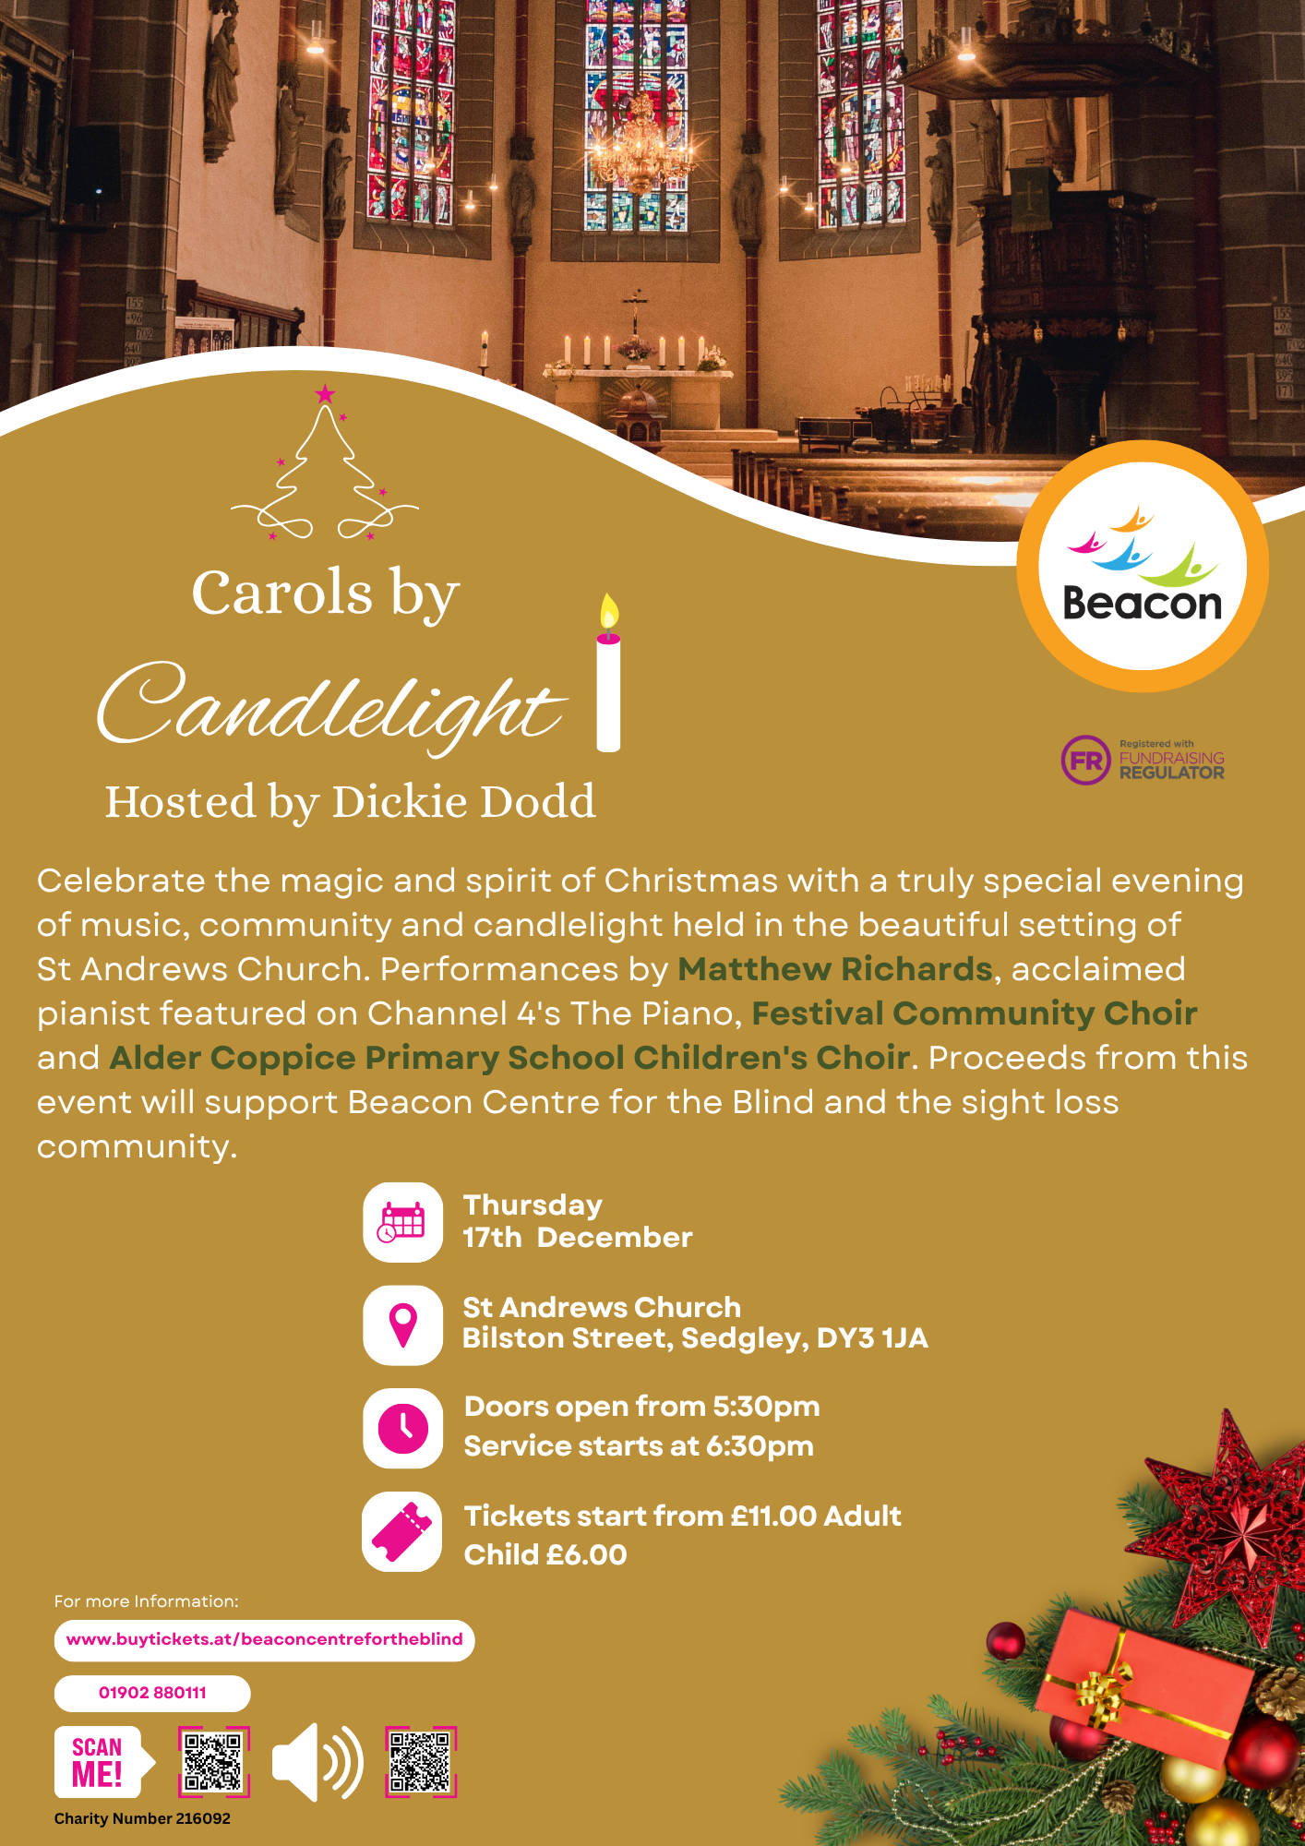
Sedgley Lifestyle Centre

We are now open Monday to Friday, 10am–3pm at our base in Sedgley. We run several activities each day including cooking, crafting, pottery, computer work, using the gym, listening to music, quizzes, and reminiscing. We keep well hydrated with tea, coffee and water, and we have the restaurant to attend for a hot meal if we do not bring sandwiches with us.
We are lively, fun and love to have a laugh. Why not come and join us for a trial day?
Contact the Beacon reception and ask for more details. Call 01902 880111 or email enquiries@beaconvision.org

Befriending Service

Have you got a free 30 minutes in the week?
Do you want to help combat loneliness?
Come and volunteer for a befriending service that is designed to help older people who might be feeling lonely! You can do this over the phone.
This volunteering is flexible to suit you while you offer friendship and support. You will be paired with someone based on common interests.
If you are interested, contact our team by calling 01902 880 111 or emailing enquiries@beaconvision.org
Contact Us
Address: Beacon Centre, Wolverhampton Road East, Wolverhampton, WV4 6AZ
Phone number: 01902 880 111.
Email: enquiries@beaconvision.org
Website: www.beaconvision.org
To find us on Facebook, Twitter, and Instagram: @BeaconCentre
Accommodation at Beacon Court
Each apartment at Beacon Court has its own front door, individual access card, two bedrooms, a store and a wet/shower room, as well as a kitchen with appliances, gas central heating, and double-glazed windows.
Beacon provides a 24/7 care team on site to deal with any emergencies 365 days a year. There’s a pull cord in each apartment that can be used in an emergency.
You also get 30 minutes a week of wellbeing time to go through anything you like such as help with post or paying bills. If you want any further information on accommodation at Beacon Court, please contact Chris Lamb on 01902 882 170 or email christopher.lamb@bromford.co.uk

To unsubscribe from this newsletter, please contact us on 01902 880111 or email enquiries@beaconvision.org

